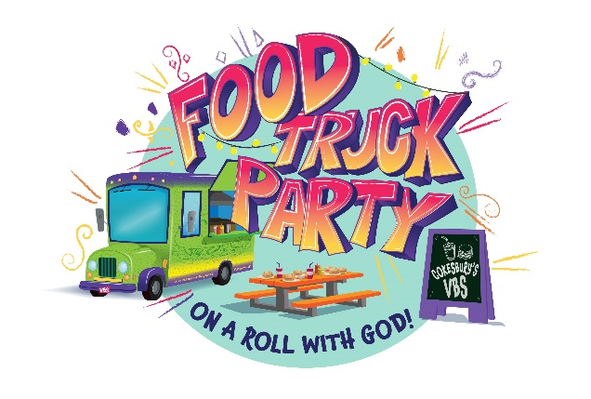
VBS Registration Form
August 1 – August 5, 2022
6-8:30pm
Immaculate Conception Church
522 Main Street
Marydel, Maryland 21649
410-482-8939

PARENT INFORMATION

Parent(s): ________________________________________________________________________________

Address: _________________________________________________________________________________

Phone: ____________________________ Phone # during VBS: ____________________________

Email: ___________________________________________________________________________________

EMERGENCY CONTACT INFORMATION
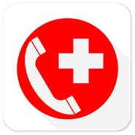
Emergency contact person: ________________________________________________________

Relationship to child/children: _______________________ Phone: _______________________

Who is allowed to pick up child/children? _____________________________________________

CHILDREN'S NAME, AGE AND MEDICAL INFORMATION

Child’s name: ____________________________________________ Age: ________ Grade last year: _________

Any allergies or medical conditions? No Yes: ________________________________________________

Child’s name: ____________________________________________ Age: ________ Grade last year: _________

Any allergies or medical conditions? No Yes: ________________________________________________

Child’s name: ____________________________________________ Age: ________ Grade last year: _________

Any allergies or medical conditions? No Yes: ________________________________________________

Child’s name: ____________________________________________ Age: ________ Grade last year: _________

Any allergies or medical conditions? No Yes: ________________________________________________

Child’s name: ____________________________________________ Age: ________ Grade last year: _________

Any allergies or medical conditions? No Yes: ________________________________________________

FIRMA__________________________________________________________________________________

