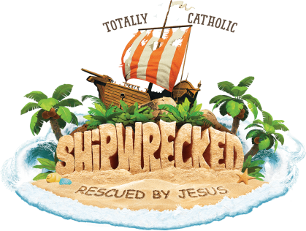
VACATION BIBLE SCHOOL
July 30- August 3, 2018: 6-8:30pm
Immaculate Conception Church
522 Main Street
Marydel, Maryland 21649
410-482-8939

Parents: ______________________________________________________________________________

Address: ______________________________________________________________________________

______________________________________________________________________________________

Phone: _______________________________________________________________________________

Phone number during VBS: _______________________________________________________________

Emergency contact person: _______________________________________________________________

Number: _______________________________________________________________________________

Who is allowed to pick up child: _____________________________________________________________

Child name: ______________________________________________________________________________

Age: ___________________ Grade last year: __________

Child: __________________________________________________________________________________

Age: ___________________Grade last year: __________

Child: ________________________________________________________________________________

Age: ___________________ Grade last year: __________

Child: __________________________________________________________________________________

Age: ___________________ Grade last year: __________

Child: ___________________________________________________________________________________

Age: ___________________ Grade last year: __________

